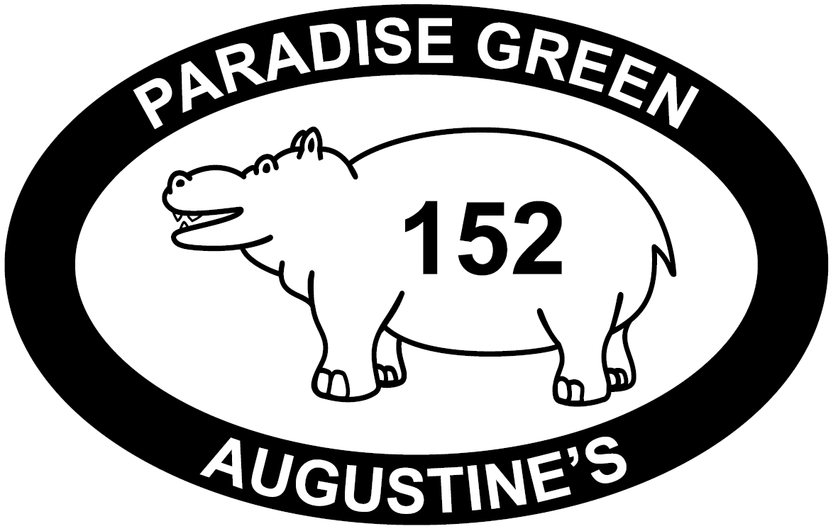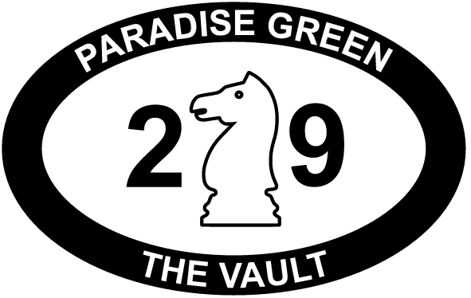

Paradise Green Promotions
Technical Details Questionnaire

This questionnaire is intended to serve a number of purposes. It should:
- encourage you to think about some of the Health and Safety aspects of your show
- provide us, the venue, with the information we require to help you during your run
- provide the information that needs to be supplied for the licensing authorities

It should not take long to complete and most of the questions have straight forward Yes or No answers.

If you want to provide some additional information, please feel free to send it by email.

If you have any questions about the answers please feel free to email us on:
augustinestech@paradise-green.co.uk

We appreciate that some of the details may not yet be finalized. Please fill in as much information as you can now. You can always send us a revised copy at a later stage. However, we do need the initial version of the forms to be returned to us as quickly as possible. It is a condition of the license that we return information contained in this form to the licensing authorities. If you do not supply this information then your performances will not be able to go ahead.

You may find more information on our website: http://www.paradise-green.co.uk/companies/

PLEASE RETURN THIS FORM TO US BY THE 4th JULY VIA E-MAIL TO
augustinestech@paradise-green.co.uk
Show Details
Name of Company:
Title of Show:

Performance Venue: Augustine’s Sanctuary
Performance Dates:
Performance Times:
Contact Details
Main Contact Name:
Telephone No:
Email:

Technical Contact Name:
Telephone No:
Email:
Technician
As a venue, we will provide technical staff to help with your technical rehearsal and to make sure that lighting and sound equipment is correctly set up for you before each show. However, we do not provide anyone to operate the lights and sound during your show. Whether or not you have technical requirements, our safety procedures require that you have somebody at the technical station throughout the show. We strongly advise you to bring your own technician.

However, in previous years, we have been able to help companies who are unable to bring a technician to get in contact with technicians from other companies in our venues who are willing to work for a fee. NB: We do not negotiate this fee for you but we can advise you of current rates of pay.

Are you bringing your own technician?

Are any technically competent persons in your company interested in working for another company?

If YES, Please give their name, telephone number and email:
Name | Telephone Number | Email

Set & Props
Please bear in mind the limited storage space within the venues. Whilst we make every effort to accommodate all the set we can’t guarantee we can fit everything in, especially if you are bringing particularly large items.

Are any of your set items or props a potential fire hazard? Check against the following list of things to avoid:

- Expanded polystyrene. This can never be made flameproof.
- Foam rubber (including cushions and upholstery), unless it carries a label saying it meets fire regulations. Older foam rubber releases highly toxic fumes when it burns.
- Loose paper (books are OK; if characters need to read papers or magazines, the quantity should be kept to a minimum, and you should ensure they are put away safely when not in use)
- Cardboard. Don’t be tempted to save weight or cost by building your set from cardboard; it generally isn’t acceptable.
- Synthetic materials. If you need to use drapes, scrims, gauze etc., they must be fully flameproofed, which is difficult to achieve with synthetic materials. Nylon net curtain etc. is unacceptable. Synthetic materials should be avoided even in costumes so far as possible.
- Man-made fibres such as polypropylene (often found as blue rope, cheap “tarpaulin” covers etc.)
- Most plastics. Things such as bin bags, carrier bags, film.

Further notes for your guidance:

- Potentially combustible materials such as cloth and timber must be flame proofed using a recognised product such as FlameCheck or FlameBar. Home-made flameproofing solutions are not allowed.
- Costumes need not be treated, as some people are sensitive to the chemicals contained in the fireproofing treatments. This also applies to bed linen etc.
- The treatments can be sprayed or painted on, or the material can be dipped in the solution. Complete and even penetration is essential for effective treatment; two or three light applications can be more effective than one heavy one.
- Make sure you use the recommended dilution; if the solution is too strong, it may cause white crystals to form on the surface of the material.
- Since the treatments are water soluble, they will be removed if you wash a treated item, and will need to be reapplied.
- We can advise you on how to buy FlameCheck.
- Hardboard should be painted on both sides.
- Emulsion paint has a fire retardant effect, and is preferable to solvent based (gloss) paint.

If in doubt, test your materials:

- Cut off a small piece
- Find a sheltered, outdoor space, where there is nothing to catch fire
- Hold the material with tongs or pliers
- Light a match and hold it against the material for 10 seconds
- If the material continues to burn after the match is removed, it is NOT acceptable.

We will carry out this test ourselves on anything we consider “suspect” (and, of course, the fire inspectors may do the same), and you will not be allowed to use anything that fails the test.

If you need a flame effect please use a battery powered candle. These are available in a number of styles, although the “tealight” variants are the easiest to get hold of. Please email if need help locating them.
Are you bringing any set? E.g. Furniture, Flats, Rostra, Scaffolding etc.

Please give a brief description of your set, props and their construction materials. For large set items, please email plans where possible.

Description | Type | Construction Materials | Flameproof

Lighting
The list of lantern types available is in the technical specifications attached to your contract (They are also on the web site). Also within your contract are the details of the number of specials you are able to request. Each special is generally one lantern, or a pre-paired wash.

Each year a number of companies attempt to get round these restrictions by offering to bring equipment from their own venues. It is very rare that we can allow this. The limited number of specials allowed to a company doesn’t reflect a lack of lanterns; it is due to power limits and the finite space in the grid. If you have problems with converting your design to a Fringe stage then please feel free to get in touch and our in house lighting technicians will be happy to offer their advice.

The sanctuary has 6 wash lights which feature CMYK colour mixing. These are controlled from the lighting desk.

What specials do you require? spots, gobo projection, back light etc. Please describe how you intend to use them.

Do you wish to put any lanterns anywhere other than the lighting grid? Floor stands, booms etc?

If so, please describe what you require

Do you have any practicals as part of your set? Eg Table lamps or Birdies built into set items.

If so, please describe them

Do you require a strobe? (subject to an additional fee)

Do you require a Followspot? (subject to an additional fee)

Sound
Are you using recorded sound?

If so, what do you require?

CD (2 available) | 0
MiniDisc | 0
Other (Please specify)

Are you using live music/effects?

Please describe your live sound

Will you require amplification of voices?

Will you require amplification of other live sounds?

How many microphones do you require? (These are subject to a small hire fee)
0

How many DI boxes do you require? (These are subject to a small hire fee)
0

Do you need a Keyboard/Electric Piano for your show?

If so will you be bringing a Keyboard/Electric Piano with you?
(if needed we can hire one for you and pass the cost onto your company. This cost may be shared if there is more than one company using the equipment in the space)

If you are bringing a Keyboard/Electric Piano, would you be willing to hire it to other companies in your space for a fee?

Electrical equipment
Are you bringing any electrical appliances for use in your show?

If YES, please give details:
We will expect to be shown the PAT test label or a certificate of testing for each item. This includes new items of equipment. Any items which are not suitably tested or certified, or where we have reasonable concerns over the current state of the equipment, will be tested by us before you will be allowed to use them. There will be a charge for each test we perform.

Description | Usage | PAT certificate
The audience
Are you planning on involving the audience with any part of your show e.g. running into the seating areas, firing water pistols, getting audience members on stage?

If YES, please explain below:
NB: You must include this in your risk assessment (See the end of this form)

Projectors
Are you planning to use a projector?

If yes, what do you intend to project? Eg. Slides, Data, Video, etc.

If yes, where will the projector be focused?

Do you intend to bring your own projector?
Because we only have a limited amount of space in which to rig equipment it may not be possible to accommodate a projector in the grid. Priority will be given to projectors used by multiple groups, ie hired through PGP. Often the only alternative is to project from a seat which will reduce your audience capacity (by up to 3 seats) and may be blocked.

Ignition Sources
The “Smoking, Health and Social Care (Scotland) Act 2005” prohibits smoking in Theatres (amongst other locations). The ban includes herbal alternatives. NO smoking will be allowed in the venue at ANY time.

Wherever possible you should use an alternative to an ignition source. For example, battery powered “tea lights” are available.

Are any sources of ignition used in your show (for example candles, oil lamps, any naked flame etc.)?

If YES, give details:
NB: You must include each ignition source in your risk assessment (See the end of this form)

Pyrotechnics
Are you intending to use any pyrotechnics in your show?

If YES, give details:
NB: You must include each effect in your risk assessment (See the end of this form)

Other Special Effects
Are you planning to use equipment to create special effects during your show? Eg, Smoke machines, etc.

If yes what equipment?
NB: You must include each effect in your risk assessment (See the end of this form)

Are you supplying this equipment? (We may be able to hire this for subject to a fee)

Miscellaneous
Please give any other details we may need to know:

Risk Assessment
The Risk Assessment form follows. Please think very carefully about the risks involved in your show.

Hazards will include, but are not limited to:
- any use of pyrotechnics or special effects
- having audience members on-stage
- ignition sources, such as candles
They can also include unstable set items, trip hazards, sharp set/props, etc.

The three main risk groups are:
- Actors
- Crew
- General Public

Control measures are designed to reduce the chance of an incident causing a bigger problem. For example, keeping hot items away from things that could potentially burn. You also plan for what might go wrong. So, if you needed to use a candle on stage you would control the risk by “lighting and extinguishing it on stage; Stage Manager with Fire Extinguisher”.

The responsible person is someone who is tasked with ensuring the safety of the effect. In the candle example above it would probably be the Stage Manager. They will need to be competent with any equipment they require.

The “Risk” is the residual risk after you have considered and applied your control measures. Remember that your control measure may not be able to cope. For example, whilst a fire extinguisher may be very good at small fires they are generally ineffective once a fire has got larger. As a general rule we only consider hazards with a Low residual risk to be acceptable.

A simple guide to Risk Assessment is available from the HSE: http://hse.gov.uk/pubns/indg163.pdf

The council and the fire service have defined the following:
Severity
Catastrophic | Multiple deaths / life threatening injuries
Major | A single death / life threatening injury or injuries to a number of people who require hospitalisation
Significant | A single injury which requires hospitalisation or injuries to a number of people who require first aid treatment
Minor | A single injury which requires some first aid treatment. Visitors feel anxious and are concerned about their safety
Negligible | No real harm: no more than inconvenience, discomfort, frustration.
Likelihood
Likely | It could be reasonably expected to happen in the foreseeable future
Possible | There are reasons to suggest that it could happen
Unlikely | Could occur under certain circumstances
Very unlikely | There are no reasons to suggest that it will happen

The severity and the likelihood form a matrix which defines the overall risk rating:

Risk Rating
 | Likelihood
Severity | Likely | Possible | Unlikely | Very unlikely
Catastrophic | A | A | B | E
Major | A | B | C | E
Significant | B | C | D | E
Minor | C | D | E | E
Negligible | E | E | E | E

These codes are defined as follows:

A | Intolerable risk. Immediate action must be taken to eliminate the hazard or to eliminate its source, regardless of cost
B | Should not be tolerated unless risk reduction is impracticable or if its cost is grossly disproportional to the improvement gained
C | Should not be tolerated unless the cost of risk reduction exceeds the improvements gained
D | Broadly acceptable risk. But risk reduction should still be made if an inexpensive measure can be found.
E | Trivial Risk. No further action required.

We will normally only allow anything with a residual risk other than 'E'. 'D' will probably also be acceptable but this will need to be confirmed with us.

If you have enabled Macros then the production title, company name and performance dates/times will have been automatically filled in on the next page. The Risk Rating will also update as you select the severity and likelihood.

If you have not enabled Macros then please don’t attempt to fill in the production title, company name and performance dates/times as we will update the information. However, you must fill in the contact details. Please also remember to select the correct risk rating based on the table above.

Please let us know if any details that you have given us change.

PLEASE RETURN THIS FORM TO US BY THE 4th JULY VIA E-MAIL TO
augustinestech@paradise-green.co.uk

Risk Assessment

Venue Address: Augustine’s Venue Number: 152
41 George IV Bridge
Edinburgh

Production Title: Company Name:
Performance Dates: Performance Times:

HAZARD | GROUP AT RISK | CONTROL MEASURE | PERSON RESPONSIBLE | LIKELIHOOD | SEVERITY | RISK  RATING

Completed By: Date:
Contact Phone Number:

